Project 1 Report

CSC 4320/6320 – Operating Systems

Spring 2018

Name: Paul Vlahos

Email: [pvlahos1@student.gsu.edu](mailto:pvlahos1@student.gsu.edu)

**Part 1:**

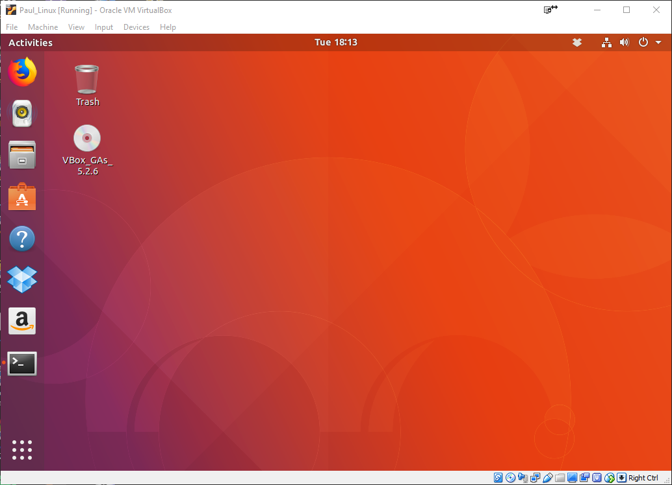

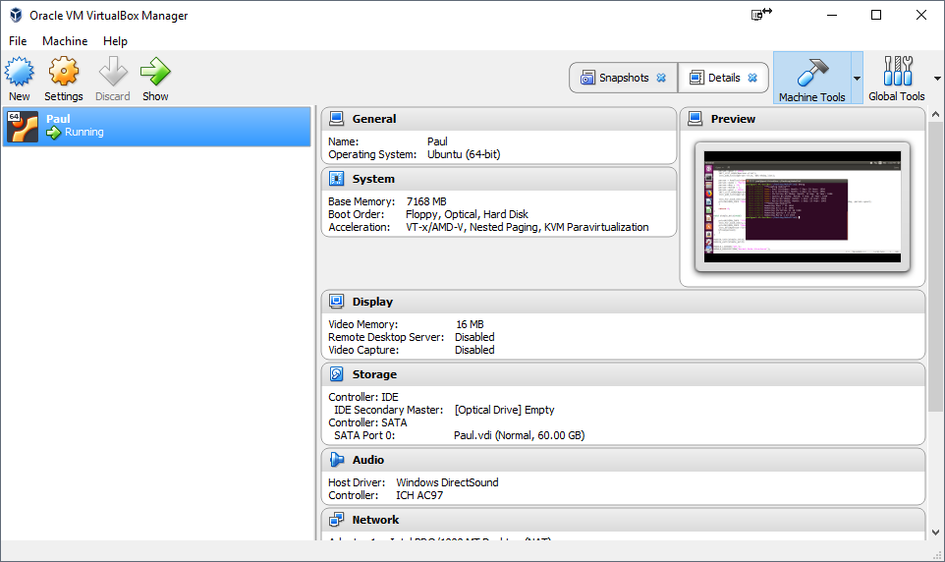

**Part 2:**





**Part 3:**

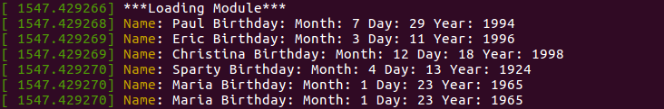

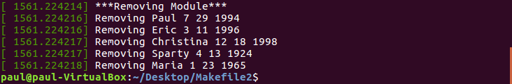

#include <linux/init.h>

#include <linux/module.h>

#include <linux/kernel.h>

#include <linux/list.h>

#include <linux/slab.h>

struct birthday

{

int month;

int day;

int year;

char *name;

struct list_head list;

};

/**

* The following defines and initializes a list_head object named birthday_list

*/

static LIST_HEAD(birthday_list);

struct birthday *person;

struct birthday *next;

int simple_init(void)

{

printk(KERN_INFO "***Loading Module***\n");

person = kmalloc(sizeof(*person), GFP_KERNEL);

person->name = "Paul";

person->day = 29;

person->month = 7;

person->year = 1994;

INIT_LIST_HEAD(&person->list);

list_add_tail(&person->list, &birthday_list);

person = kmalloc(sizeof(*person), GFP_KERNEL);

person->name = "Eric";

person->day = 11;

person->month = 3;

person->year = 1996;

INIT_LIST_HEAD(&person->list);

list_add_tail(&person->list, &birthday_list);

person = kmalloc(sizeof(*person), GFP_KERNEL);

person->name = "Christina";

person->day = 18;

person->month = 12;

person->year = 1998;

INIT_LIST_HEAD(&person->list);

list_add_tail(&person->list, &birthday_list);

person = kmalloc(sizeof(*person), GFP_KERNEL);

person->name = "Sparty";

person->day = 13;

person->month = 4;

person->year = 1924;

INIT_LIST_HEAD(&person->list);

list_add_tail(&person->list, &birthday_list);

person = kmalloc(sizeof(*person), GFP_KERNEL);

person->name = "Maria";

person->day = 23;

person->month = 1;

person->year = 1965;

INIT_LIST_HEAD(&person->list);

list_add_tail(&person->list, &birthday_list);

person = kmalloc(sizeof(*person), GFP_KERNEL);

person->name = "Maria";

person->day = 23;

person->month = 1;

person->year = 1965;

INIT_LIST_HEAD(&person->list);

list_add_tail(&person->list, &birthday_list);

list_for_each_entry(person, &birthday_list, list) {

printk(KERN_INFO "Name: %s Birthday: Month: %d Day: %d Year: %d", person->name, person->month, person->day, person->year);

}

return 0;

}

void simple_exit(void)

{

printk(KERN_INFO "***Removing Module***\n");

list_for_each_entry_safe(person,next,&birthday_list,list) {

printk(KERN_INFO "Removing %s %d %d %d", person->name, person->month, person->day, person->year);

list_del(&person->list);

kfree(person);

}

}

module_init(simple_init);

module_exit(simple_exit);

MODULE_LICENSE("GPL");

MODULE_DESCRIPTION("Kernel Data Structures");

MODULE_AUTHOR("SGG");